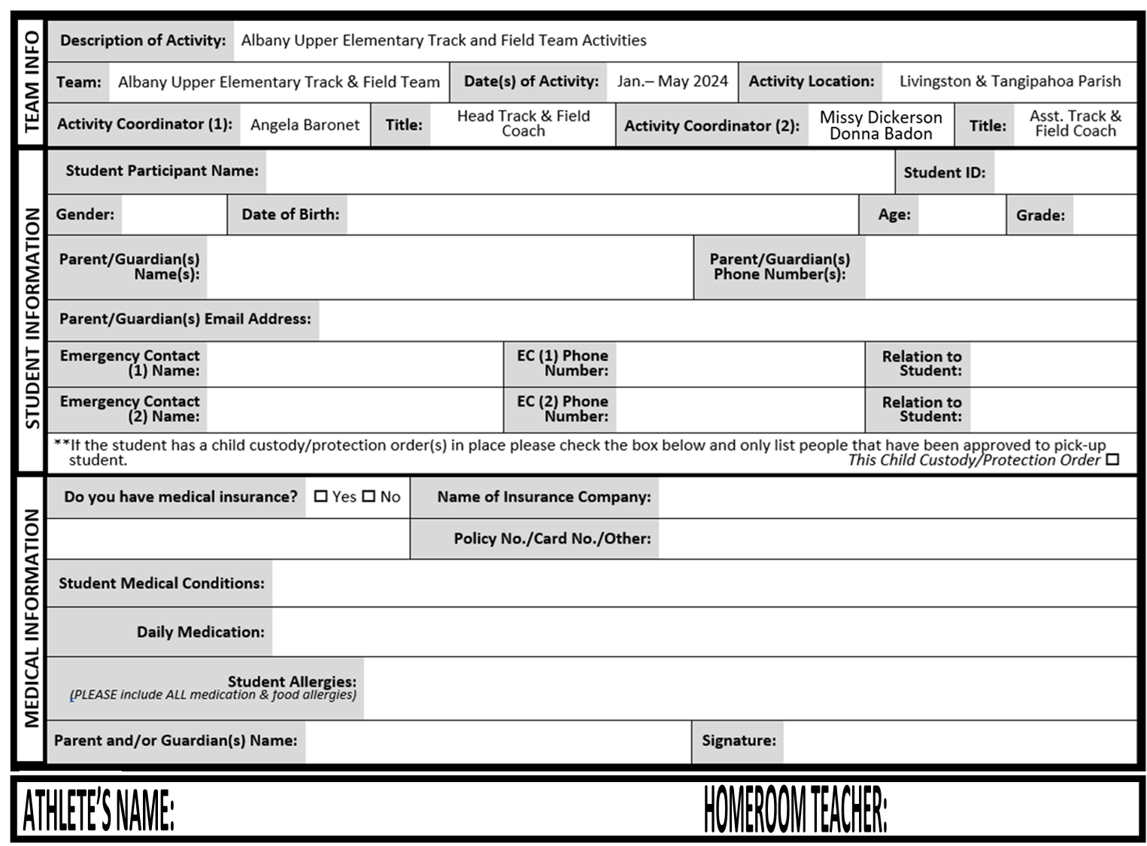

ATHLETE INFORMATION FORM